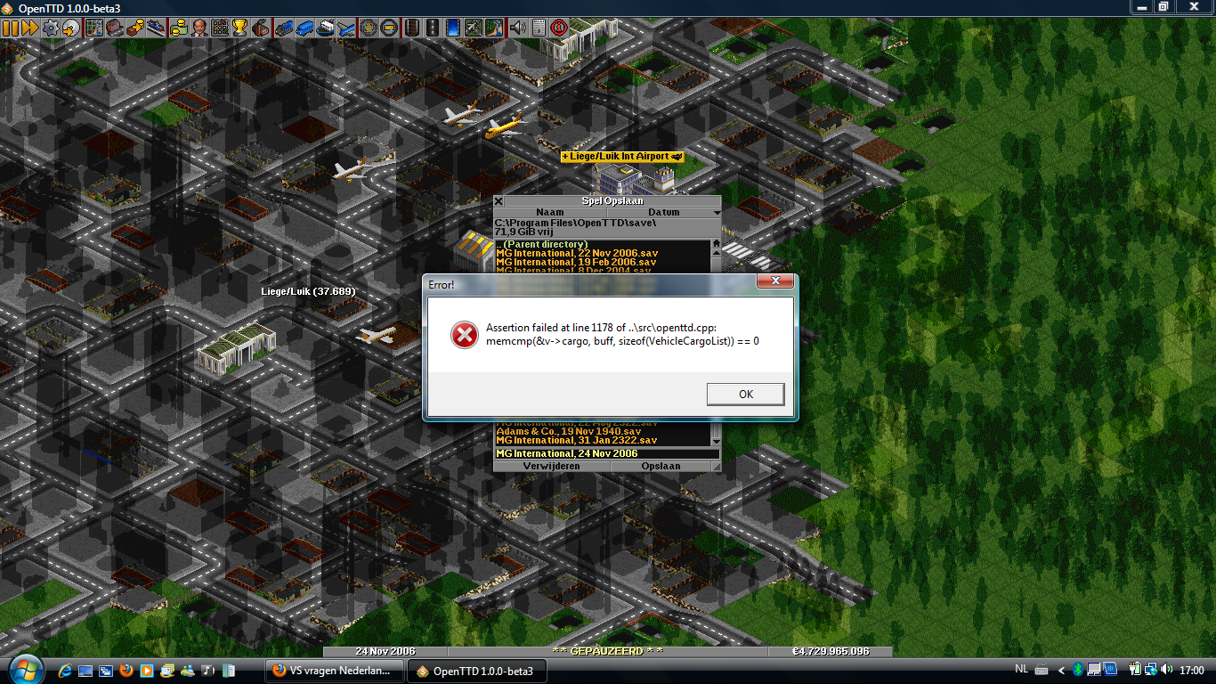

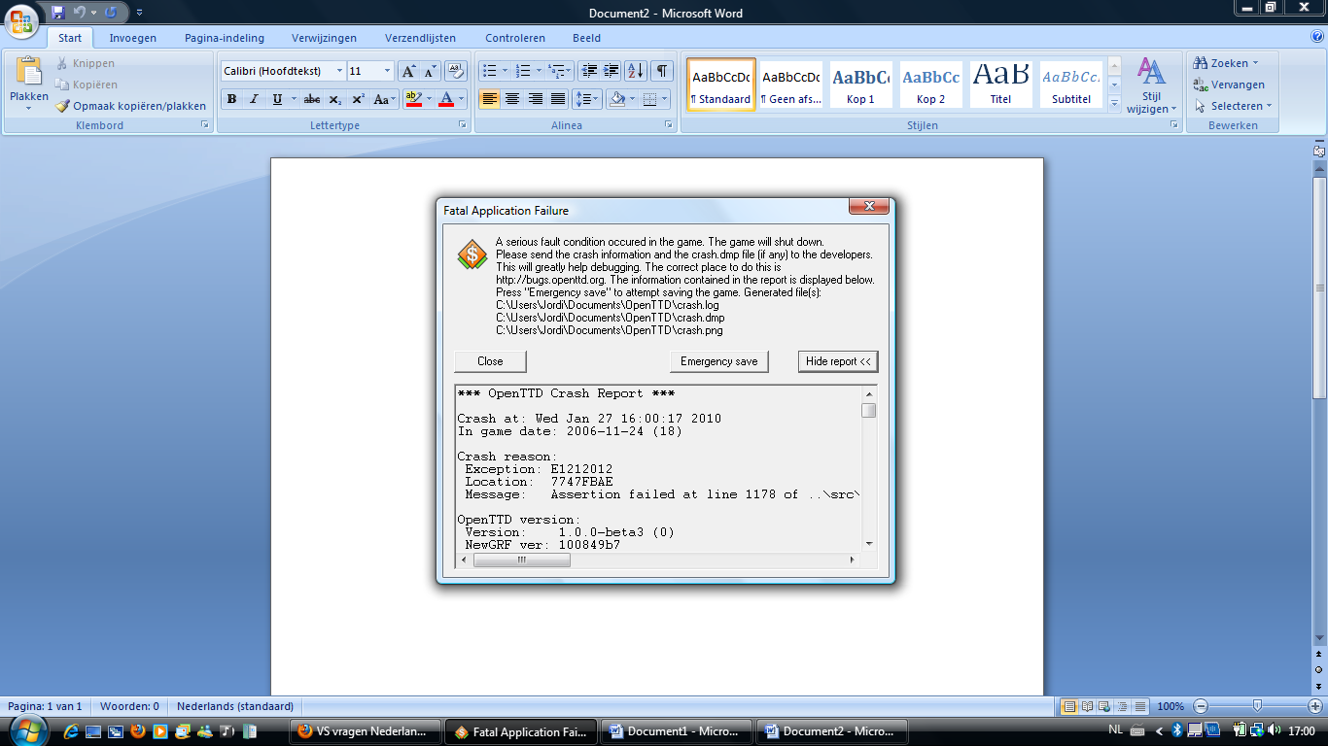

*** OpenTTD Crash Report ***

Crash at: Wed Jan 27 16:00:17 2010

In game date: 2006-11-24 (18)

Crash reason:

Exception: E1212012

Location: 7747FBAE

Message: Assertion failed at line 1178 of ..\src\openttd.cpp: memcmp(&v->cargo, buff, sizeof(VehicleCargoList)) == 0

OpenTTD version:

Version: 1.0.0-beta3 (0)

NewGRF ver: 100849b7

Bits: 32

Endian: little

Dedicated: no

Build date: Jan 20 2010 23:52:58

Registers:

EAX: 0012F5A8 EBX: 00000016 ECX: 00000000 EDX: 77F35E74

ESI: 00770F00 EDI: 00000000 EBP: 0012F5F8 ESP: 0012F5A8

EIP: 7747FBAE EFLAGS: 00200246

Bytes at instruction pointer:

C9 C2 10 00 90 90 90 90 90 8B FF 55 8B EC 51 51 83 7D 10 00 56 0F 84 7F

Stack trace:

E1212012 00000000 00000000 7747FBAE 00000000 00000000 00000000 00A69FA0

009D0000 17010016 A407CF0D FFFFFFFE 77F34E60 77EFC6C2 FFFFFFFF 00000024

0012F5F4 00000004 00000000 00000016 0012F658 00548AF9 E1212012 00000000

00000000 00000000 00617407 00000016 D2568C7C 0012FBE8 00000200 01FA60C4

77F0A296 FFFFFFFF 00000000 0012F640 00548AE9 00000001 0012F618 0012F1C4

0012FF78 0061C170 D237D60C FFFFFFFE 0012F990 0061678B 00000016 00000200

00000080 000000A0 00000018 0E00040A 00000030 00E82240 00A72F98 00000000

00000000 764B4A11 00000030 009D33E8 00000000 00000000 00000001 009D33B0

001E0484 00A69FA8 00A645C8 000C002E 00E2B9C1 00000000 00000180 01010100

0012F600 764D2DC0 0012FF78 77ED99FA 00E91153 FFFFFFFE 77F37512 77F37545

00000000 00A69FA8 00000000 00010003 0012F8EC 0012F790 764FCD80 009D0000

00000000 00A69FA0 00000001 0012F8EC 00000001 00000000 00000000 00000556

000002E2 00000000 007C34D8 00000010 0000001C 0000000F 002B0444 00000006

00000000 00000000 00000133 00000001 50022080 00000000 00000000 00000035

00007F01 00A69FA8 00000001 0000001E 00000020 7F01FFFF 0000009F 00000000

000001A0 00A6A028 0012F8E0 764FD2CA 00000010 0012FBE8 00000200 764FD302

00000001 00000008 00000004 00000006 0024077C 00000000 00000000 00000000

00000000 00000000 764FD31C 00000000 00000001 00000019 0000000F 0000000D

0000000D 40100AF3 018506F0 6D100F7D 00000000 00000017 00000005 00000000

00000000 01EA0000 01EA0000 00003BF8 000007FF 07730000 0794E888 0000077F

01EA00C4 01EA2C30 00008001 0012F874 77F11FF9 01EA0000 008F6860 00000000

00000000 00000000 01EA0000 0499DEE0 56005600 00000019 00020025 04A91389

01EA0000 0490EB78 00000000 0012F8BC 01EB0048 77F0A74F 7709A41F 01EB07D8

049C01D0 01EB0048 01EB00D8 01EB0048 00000000 0499DE68 01EAE4A8 0012F880

Operating system:

Name: Windows

Release: 6.0.6002 (Service Pack 2)

Compiler: MSVC 1500

Configuration:

Blitter: 8bpp-optimized

Graphics set: OpenGFX

Language: dutch.lng

Music driver: dmusic

Music set: NoMusic

Network: no

Sound driver: win32

Sound set: NoSound

Video driver: win32

AI Configuration (local: 0):

0: Human

Libraries:

FreeType: 2.3.11

ICU: 4.2.1

LZO: 2.03

PNG: 1.2.40

Zlib: 1.2.3

Module information:

C:\Program Files\OpenTTD\openttd.exe handle: 00400000 size: 3640832 crc: B54B444C date: 2010-01-20 23:55:54

C:\Windows\system32\ntdll.dll handle: 77ED0000 size: 1202168 crc: 11EF8EE5 date: 2009-04-11 06:27:49

C:\Windows\system32\kernel32.dll handle: 77440000 size: 891392 crc: 1164F2B3 date: 2009-04-11 06:28:20

C:\Windows\system32\WINMM.dll handle: 74EB0000 size: 189952 crc: 3E8CBFF5 date: 2009-04-11 06:28:25

C:\Windows\system32\msvcrt.dll handle: 77A20000 size: 679936 crc: B0E5331E date: 2009-04-11 06:28:22

C:\Windows\system32\USER32.dll handle: 764A0000 size: 627712 crc: 80F0F3C5 date: 2009-04-11 06:28:25

C:\Windows\system32\GDI32.dll handle: 77650000 size: 297472 crc: 69625D80 date: 2009-04-11 06:28:19

C:\Windows\system32\ADVAPI32.dll handle: 77370000 size: 800768 crc: D7864B03 date: 2009-04-11 06:28:17

C:\Windows\system32\RPCRT4.dll handle: 76540000 size: 784896 crc: 35185859 date: 2009-04-23 12:15:07

C:\Windows\system32\ole32.dll handle: 77C90000 size: 1316864 crc: CB56BE6B date: 2009-04-11 06:28:23

C:\Windows\system32\OLEAUT32.dll handle: 775B0000 size: 563712 crc: 12E9F438 date: 2009-04-11 06:28:23

C:\Windows\system32\OLEACC.dll handle: 74E70000 size: 234496 crc: 82CE51D9 date: 2009-10-08 21:08:01

C:\Windows\system32\WS2_32.dll handle: 77E90000 size: 179200 crc: 5D581120 date: 2008-01-21 02:25:16

C:\Windows\system32\NSI.dll handle: 77EC0000 size: 8192 crc: 10729B39 date: 2008-01-21 02:25:11

C:\Windows\system32\SHELL32.dll handle: 766A0000 size: 11584000 crc: 766AA8BB date: 2009-04-11 06:28:24

C:\Windows\system32\SHLWAPI.dll handle: 77E30000 size: 353280 crc: 681AC986 date: 2009-04-11 06:28:24

C:\Windows\system32\IMM32.DLL handle: 77E10000 size: 114688 crc: 8D83D50A date: 2009-04-11 06:28:20

C:\Windows\system32\MSCTF.dll handle: 77BC0000 size: 807424 crc: 78787E19 date: 2009-04-11 06:28:20

C:\Windows\system32\LPK.DLL handle: 775A0000 size: 23552 crc: 2E03F135 date: 2009-06-15 14:52:42

C:\Windows\system32\USP10.dll handle: 772F0000 size: 502272 crc: 33F7104F date: 2009-04-11 06:28:25

C:\Windows\WinSxS\x86_microsoft.windows.common-controls_6595b64144ccf1df_6.0.6002.18005_none_5cb72f96088b0de0\comctl32.dll handle: 751A0000 size: 1686016 crc: 1453762E date: 2009-04-11 06:21:38

C:\Windows\system32\SHFolder.dll handle: 70930000 size: 7168 crc: 1CA14A5C date: 2006-11-02 09:46:13

C:\Windows\system32\wdmaud.drv handle: 73000000 size: 167424 crc: AE942463 date: 2009-04-11 06:27:12

C:\Windows\system32\ksuser.dll handle: 731E0000 size: 4608 crc: 4C647881 date: 2006-11-02 09:46:05

C:\Windows\system32\MMDevAPI.DLL handle: 74F80000 size: 150528 crc: 481F98E7 date: 2009-04-11 06:28:20

C:\Windows\system32\AVRT.dll handle: 75660000 size: 12800 crc: EB589AA0 date: 2008-01-21 02:25:20

C:\Windows\system32\SETUPAPI.dll handle: 77890000 size: 1591296 crc: A225D6A1 date: 2009-04-11 06:28:24

C:\Windows\system32\WINTRUST.dll handle: 755A0000 size: 171520 crc: EE6B6CCB date: 2008-01-21 02:24:57

C:\Windows\system32\CRYPT32.dll handle: 75E00000 size: 978944 crc: CE0B7499 date: 2009-04-11 06:28:18

C:\Windows\system32\MSASN1.dll handle: 75F60000 size: 60928 crc: D62CDC5B date: 2009-09-04 11:41:59

C:\Windows\system32\USERENV.dll handle: 76300000 size: 108544 crc: CC1E5DD3 date: 2009-04-11 06:28:25

C:\Windows\system32\Secur32.dll handle: 762E0000 size: 72704 crc: C962EC8E date: 2009-06-15 14:53:43

C:\Windows\system32\imagehlp.dll handle: 77DE0000 size: 153088 crc: EEF49677 date: 2008-01-21 02:24:32

C:\Windows\system32\AUDIOSES.DLL handle: 72FD0000 size: 115712 crc: 9E346B3A date: 2009-04-11 06:28:18

C:\Windows\system32\audioeng.dll handle: 72D30000 size: 397312 crc: 17666E45 date: 2008-01-21 02:25:20

C:\Windows\system32\PSAPI.DLL handle: 76440000 size: 12288 crc: D7B812C5 date: 2006-11-02 09:46:12

C:\Windows\system32\msacm32.drv handle: 730E0000 size: 21504 crc: 28704D00 date: 2009-04-11 06:27:12

C:\Windows\system32\MSACM32.dll handle: 730C0000 size: 71680 crc: A2E8F836 date: 2008-01-21 02:25:19

C:\Windows\system32\midimap.dll handle: 72FC0000 size: 17408 crc: 9FC56E7F date: 2009-04-11 06:28:20

C:\Windows\system32\CLBCatQ.DLL handle: 76610000 size: 523776 crc: C2EBF5E6 date: 2008-01-21 02:24:49

C:\Windows\system32\uxtheme.dll handle: 754A0000 size: 240128 crc: 5F29223E date: 2008-01-21 02:24:10

C:\Windows\system32\dmime.dll handle: 729A0000 size: 178688 crc: 3063C87B date: 2008-01-21 02:24:03

C:\Windows\system32\DSOUND.dll handle: 6B6F0000 size: 444416 crc: 2196E709 date: 2009-04-11 06:28:19

C:\Windows\system32\POWRPROF.dll handle: 75750000 size: 98816 crc: F5FB120D date: 2009-04-11 06:28:23

C:\Windows\system32\dmusic.dll handle: 72A60000 size: 101888 crc: 9C95E7AB date: 2009-04-11 06:28:18

C:\Windows\system32\dmsynth.dll handle: 74010000 size: 105472 crc: A572B2E6 date: 2009-04-11 06:28:18

C:\Windows\system32\dmloader.dll handle: 74860000 size: 38400 crc: 43D1875C date: 2008-01-21 02:24:03

C:\Windows\system32\mswsock.dll handle: 75A50000 size: 223232 crc: 9C4248CA date: 2009-04-11 06:28:22

C:\Windows\System32\wshtcpip.dll handle: 75730000 size: 9216 crc: 10C50FC1 date: 2008-01-21 02:24:29

---- gamelog start ----

Tick 0: game loaded

Conversion from OTTD savegame without gamelog: version 90, 0

Revision text changed to 1.0.0-beta1, savegame version 132, not modified, _openttd_newgrf_version = 0x100048bf

New game mode: 1 landscape: 0

Tick 28017: game loaded

Revision text changed to 1.0.0-beta2, savegame version 135, not modified, _openttd_newgrf_version = 0x1000492f

Tick 42648: game loaded

Revision text changed to 1.0.0-beta3, savegame version 136, not modified, _openttd_newgrf_version = 0x100849b7

---- gamelog end ----

*** End of OpenTTD Crash Report ***